6.81: a) At maximum compression, the spring (and hence the block) is not moving, so the block has no kinetic energy. Therefore, the work done by the block is equal to its initial kinetic energy, and the maximum compression is found from 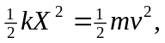 or
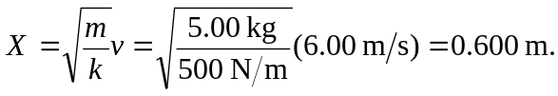
b) Solving for v in terms of a known X,
